INSTITUTO MEXICANO NORTEAMERICANO DE CULTURA

Course Examination

1st Examination

Teacher’s Name: Adriana Felisa Chávez De la Peña

Student’s Name: _____________________________________

1.- **Numbers**. Write the name of the numbers below.

a) 3 __________________________

b) 15 __________________________

c) 89 __________________________

d) 749 __________________________

2.- **Face description.** Paint the face according to the sentences below.

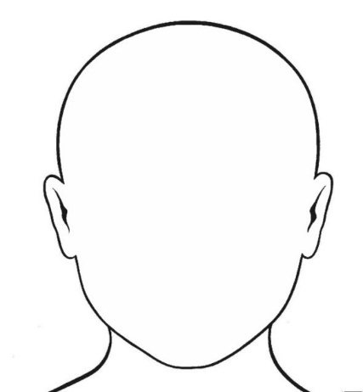

a. His eyes are blue b. His hair is black

c. His hair is curly d. His mouth is big

e. His mouth is smiling f. His hat is red

g. His glasses are black h. His nose is small

i. His nose is small j. His eyebrows are black

3.- Face description 2. Complete the 5 sentences about the boy in the picture.

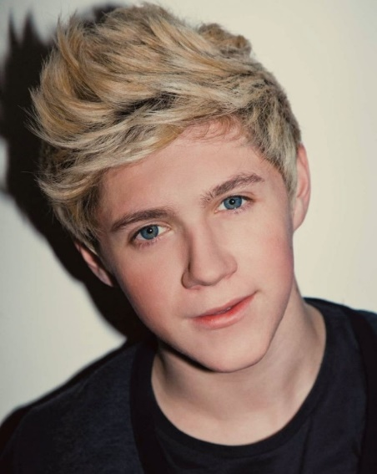

a. His eyes are _________________________

b. His hair is _________ and ______________

c. His _________________________________

d. His shirt is ___________________________

e. His mouth is _________________________

4.- Physical descriptions. Draw the silhouettes below according to the sentences presented.

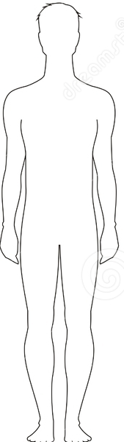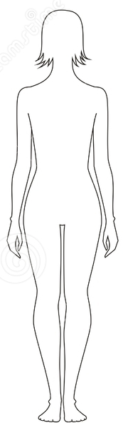

a. His hair is blond b. Her hair is brunette

c. Her jeans are blue d. His shirt is red

e. His eyes are green f. Her shirt is pink

g. Her eyes are brown h. His jeans are black

i. Her shoes are red j. His shoes are white

k. His cap is red l. Her necklace is purple

m. His watch is black n. Her jacket is purple

5.- Match the columns according to the picture.

|  |  |
| --- | --- |
| 1.. The girl is | a) next to the TV |
| 2. The TV is | b) under the desk |
| 3. The book is | c) on the bed |
| 4. The chair is | d) on the desk |
| 5. The mirror is | e) over the sink |
| 6. The jacket is | f) in the closet |

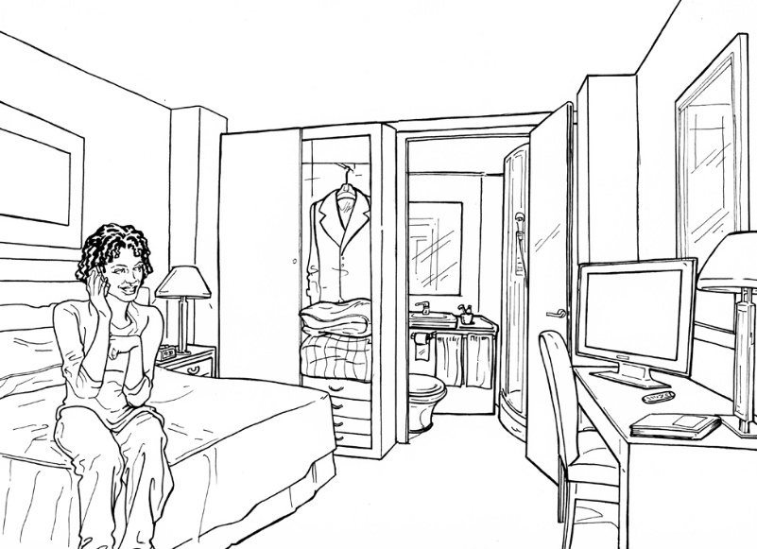

**A N S W E R S H E E T**

INSTITUTO MEXICANO NORTEAMERICANO DE CULTURA

Course Examination

1st Examination

Teacher’s Name: Adriana Felisa Chávez De la Peña

Student’s Name: _____________________________________

1.-

a._________________

b. _________________

c.____________________

d. _________________

2.-

a___________________ b_____________________

c___________________ d_____________________

e___________________ f_____________________

g___________________ h_____________________

i___________________ j_____________________

3.-

a)_________________ b)_____________________ c)____________________

d)_________________ e)_____________________

4.-

a___________________ b_____________________

c___________________ d_____________________

e___________________ f_____________________

g___________________ h_____________________

i___________________ j_____________________

k___________________ l_____________________

m___________________ n_____________________

5.-

1 ____ 2 ____ 3 ____ 4 ____ 5 ____ 6 ____